*Florida International University*

*School of Computing and Information Sciences*

ASI PantherCentric 1.0 User Guide

**Team Members**:

Jake Lopez

Alfredo Santoyo

Rolando Moreno

Pricsila Cordova

**Product Owner**:

Myrian Herlle

**Mentor:**

Myrian Herlle

Francisco Ortega

**Instructor:**

Masoud Sadjadi

### View List of Students Being Tutored

As an administrator logs into the portal, click on the button for Current Students. Next you will see the current list of students being tutored.

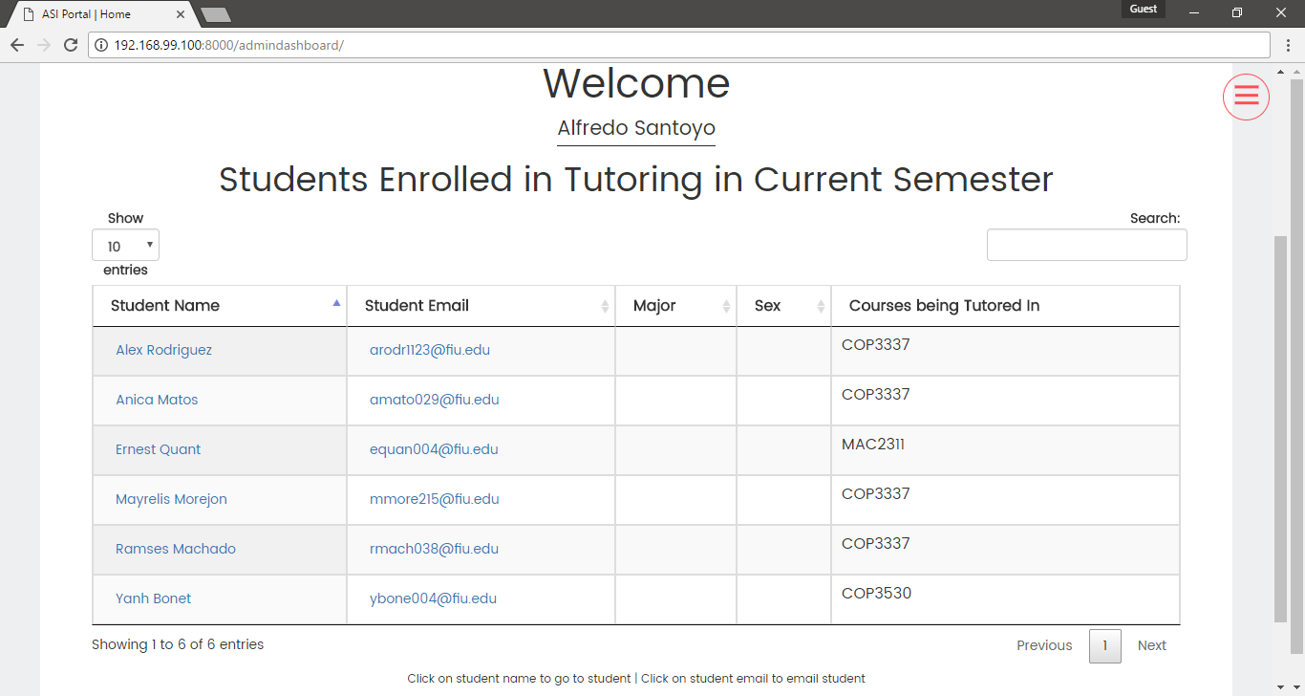

While looking at this list you can sort it by student name, major, or even search for a student at the top right corner of the table.

### View Specific Student Details

To view the specific details, you can click on the name of any student on the list.



Next you will see the profile view of said student. You are able to their name, courses they are getting tutored, major, sex, phone number, and email.

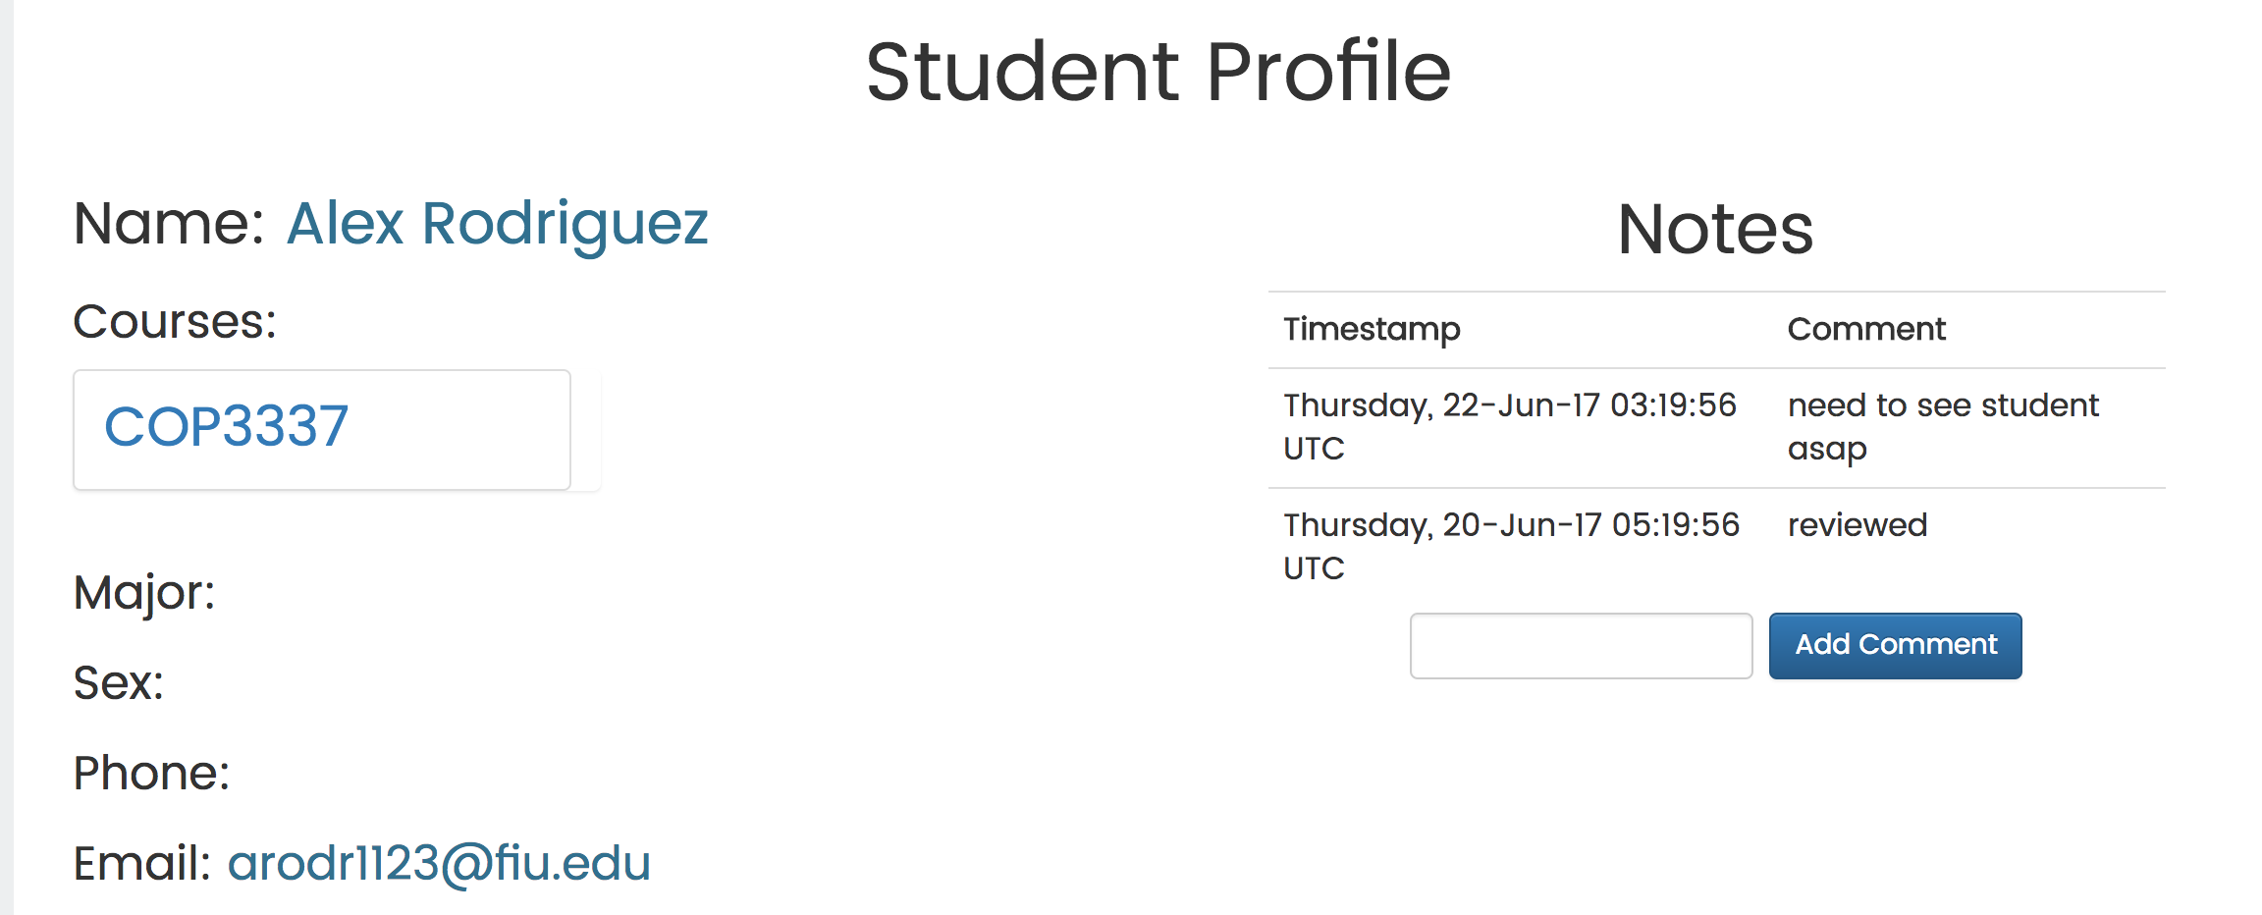

### Write Notes About Student

You also have the option to write notes about a student on the profile view. You will see a notes panel in this page. You may type on the space provided and click on “add a comment”.



### View Course Data Table

# 

# 

# Admin Manual

To login, enter user name and password and press login.

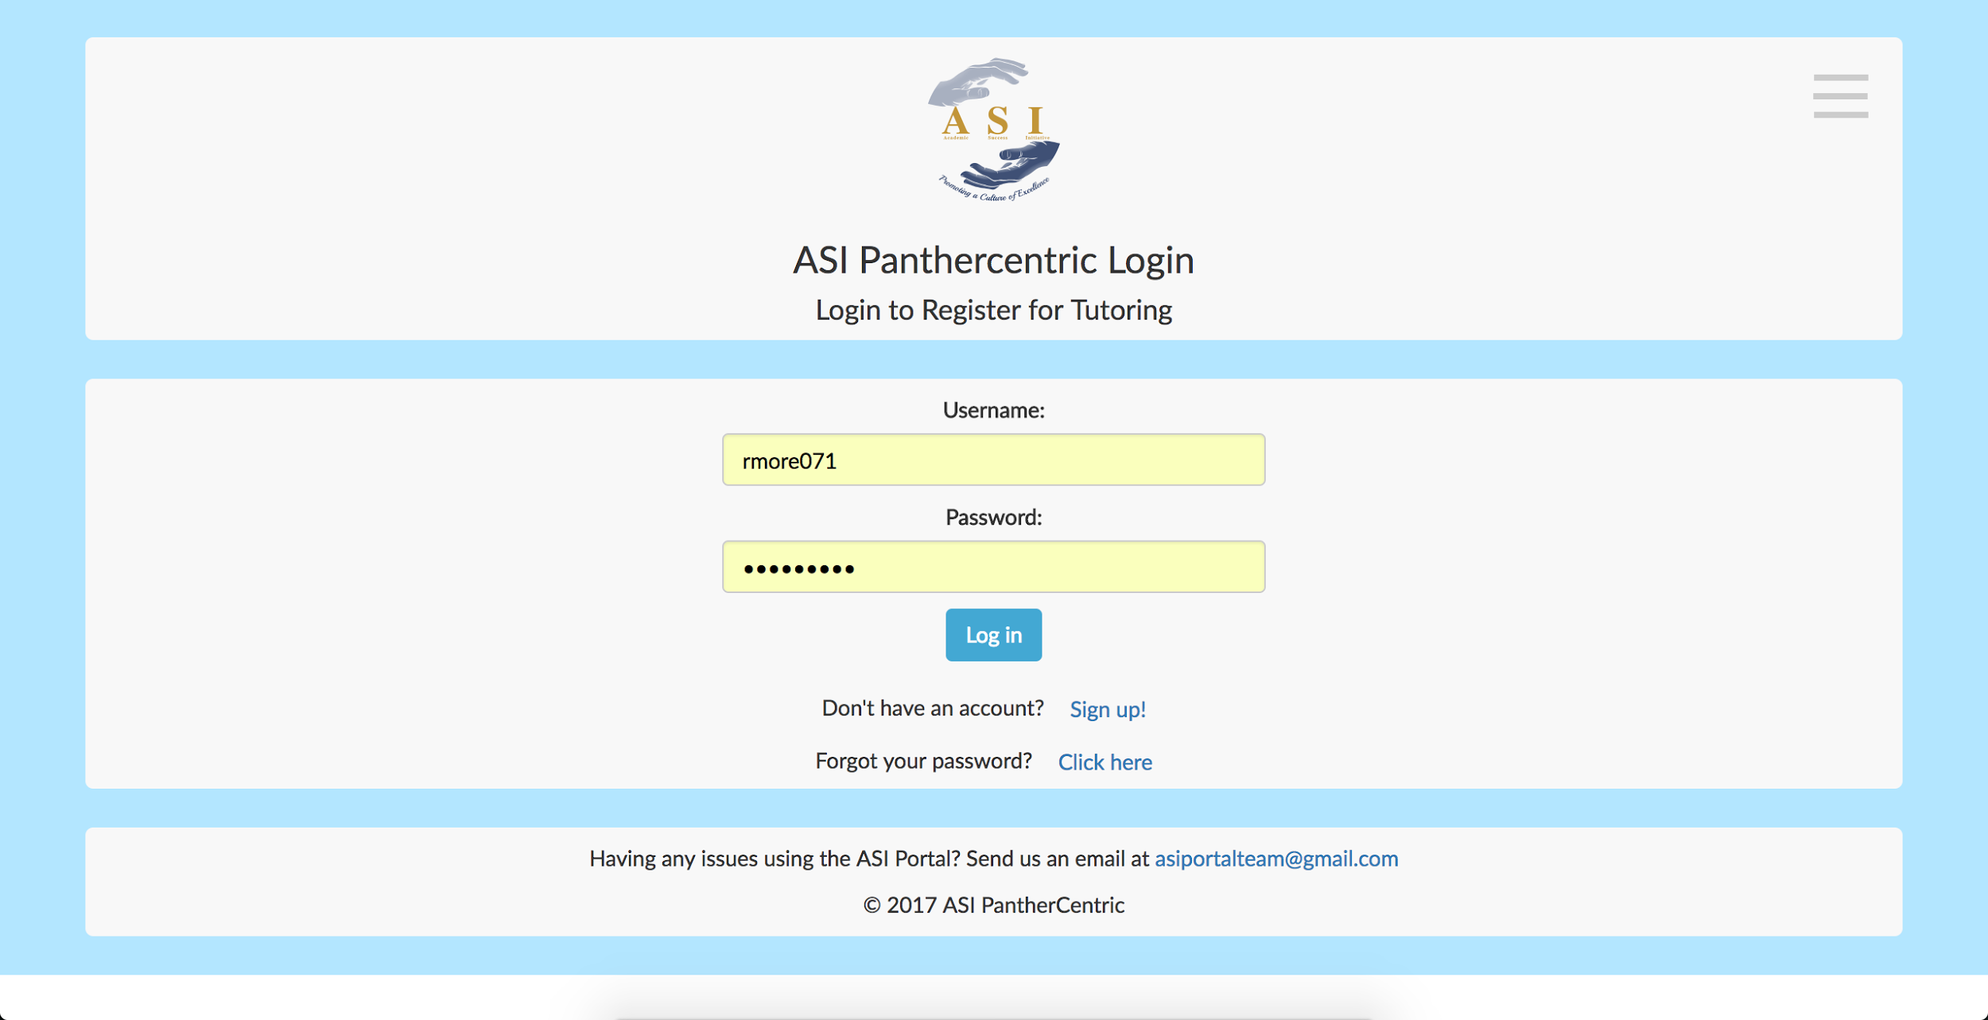

You will be in the administrator menu page.

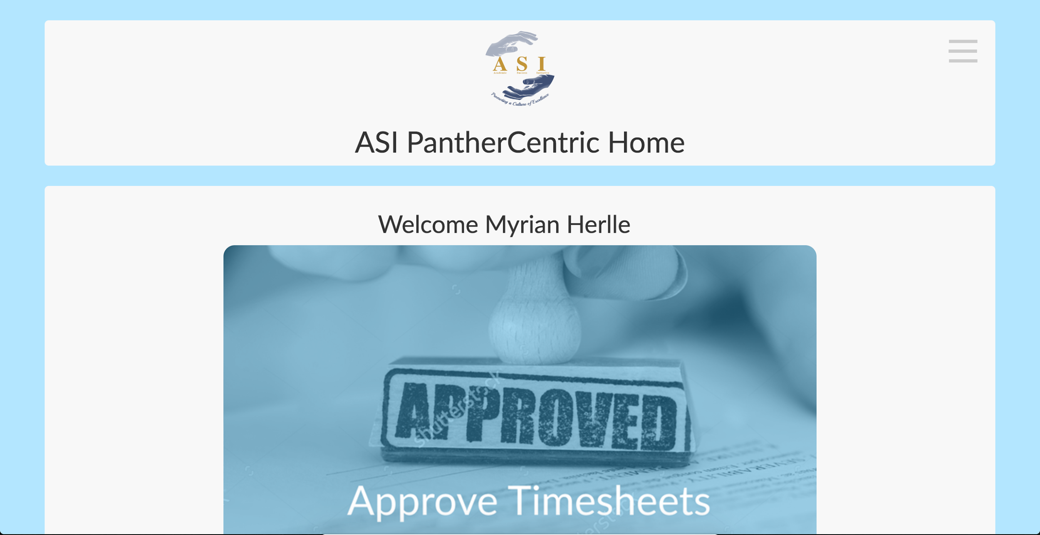

You can then select from three tasks:

Approve Timesheets - Approve ambassador timesheets

Admin Dashboard - View individual student details and progress.

Semester Report - View report of overall progress on semester.

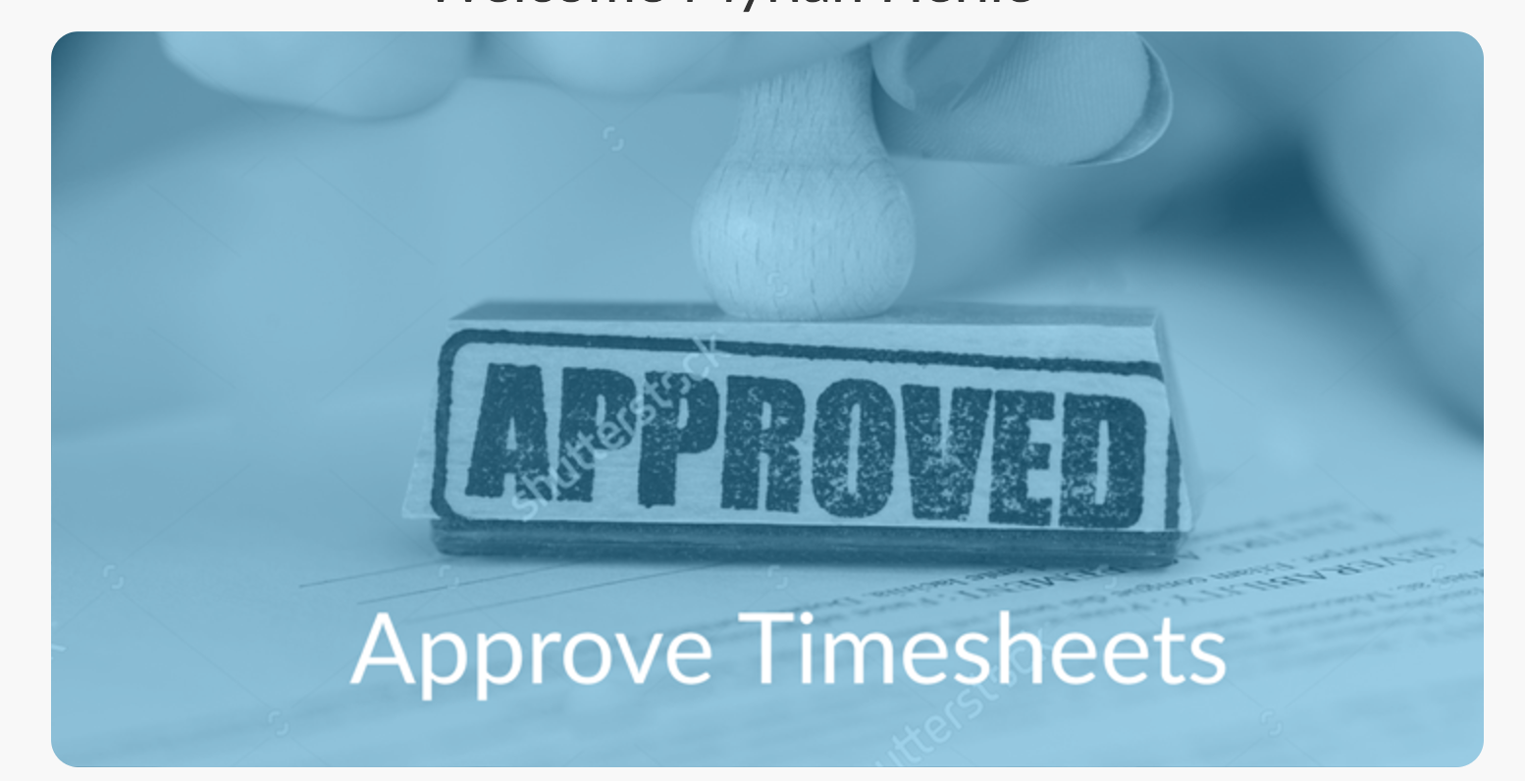

If you click on Approve Timesheets you will be able to approve ambassador timesheets.

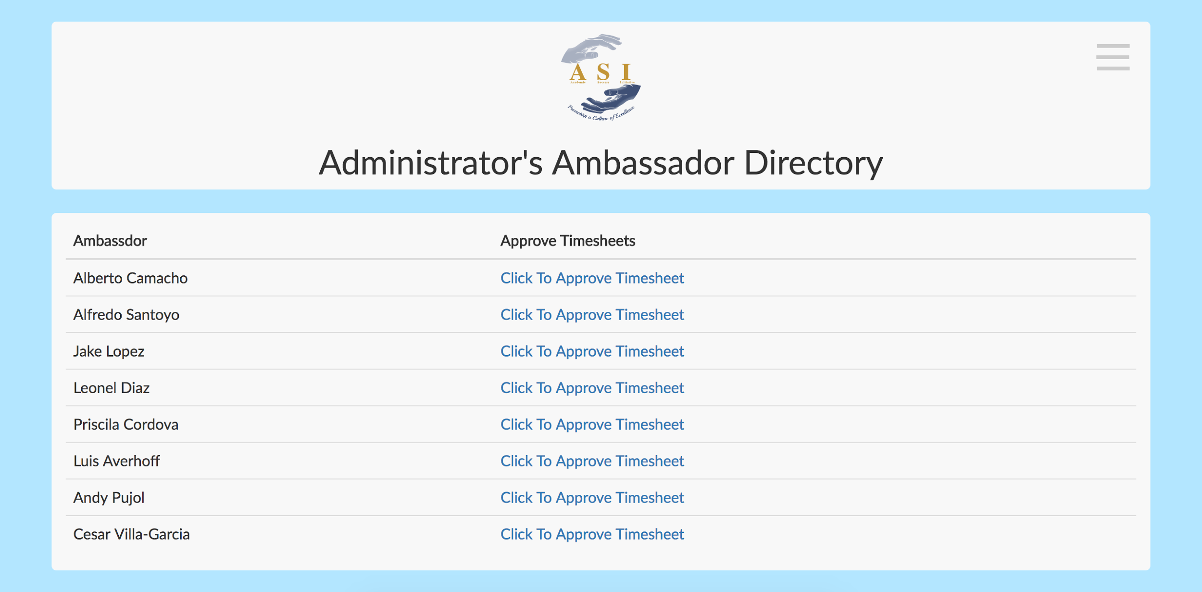

List of ambassador timesheets to approve. Clicking on one will go to the individuals timesheet.

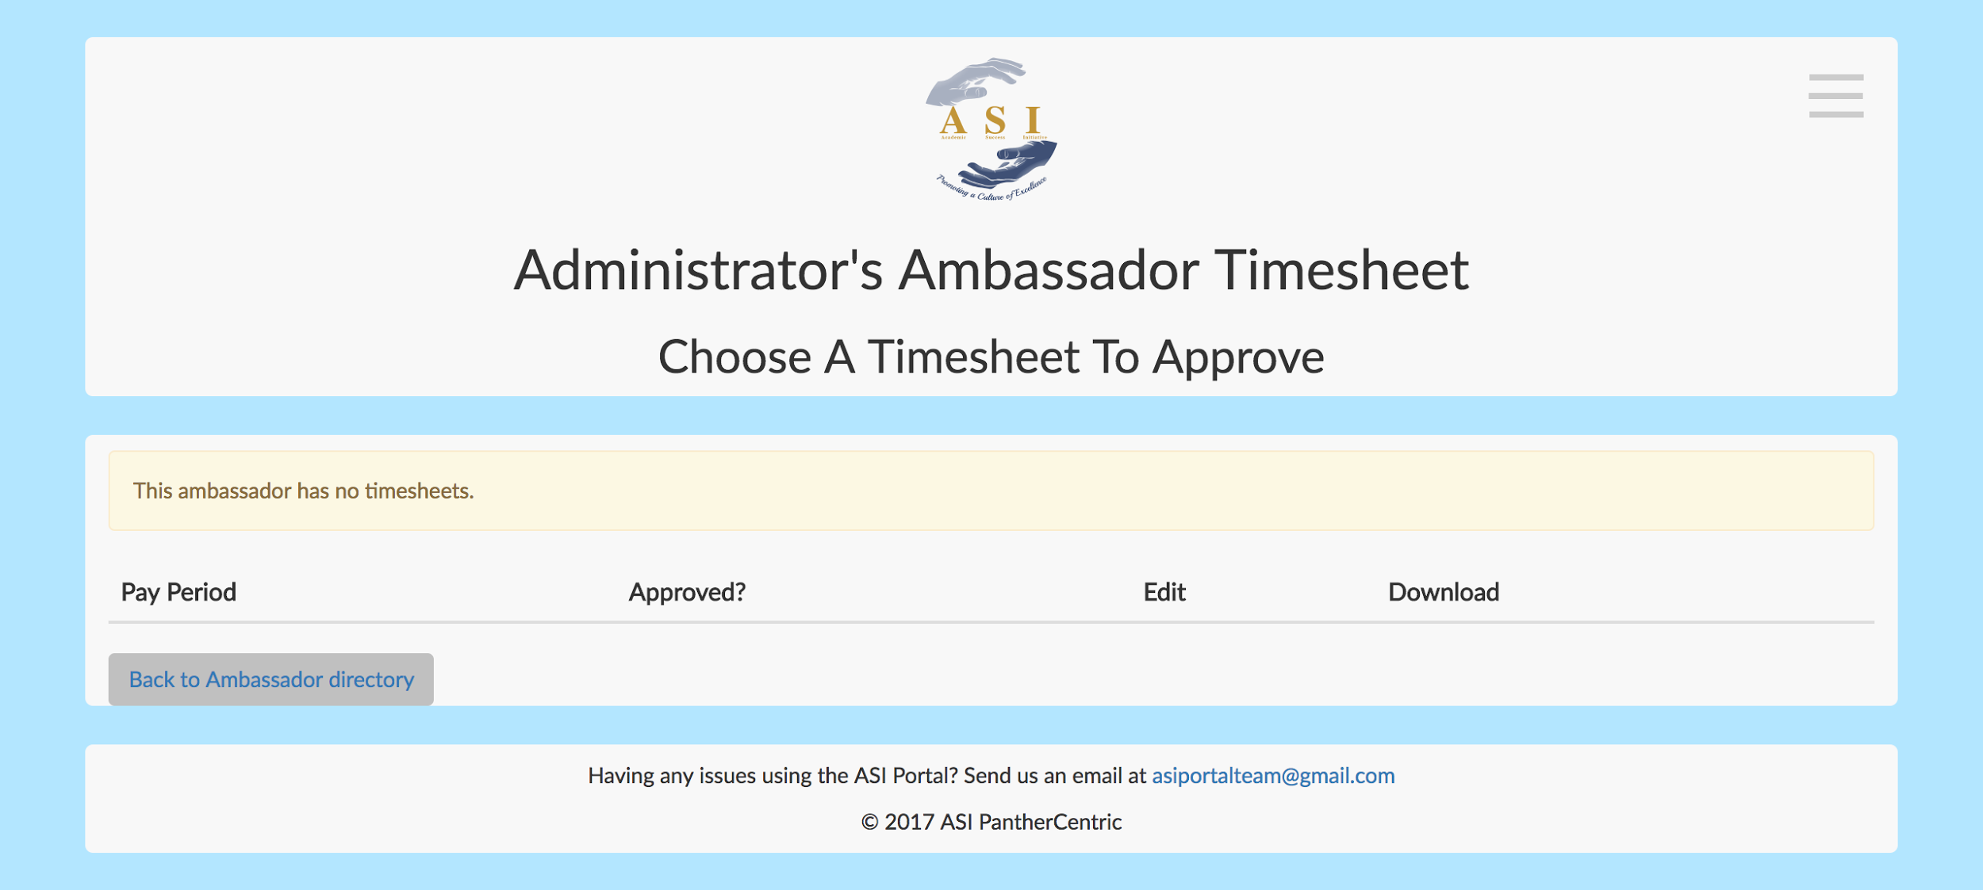

If you click on Admin Dashboard, you will be sent to view student profiles.

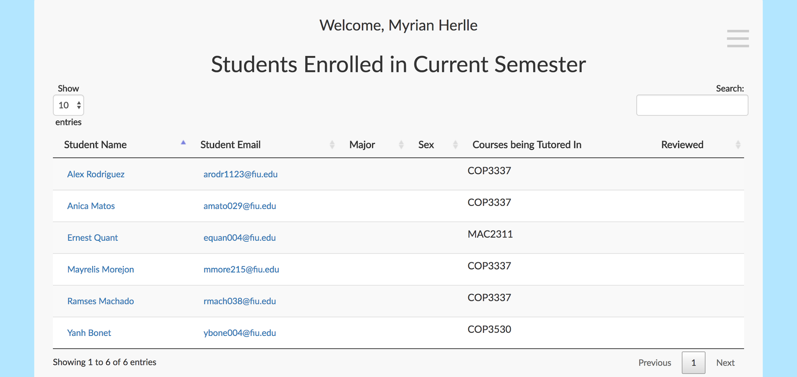

Click on student name to go to individual student profile.

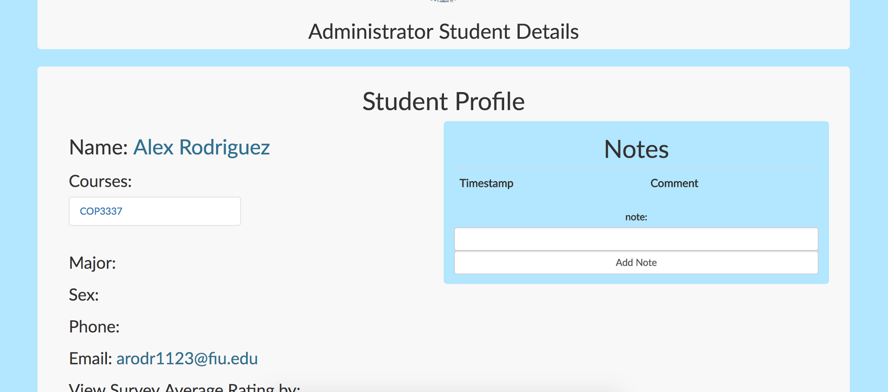

Here you can click to add notes about student or click to view surveys completed for each tutoring session.

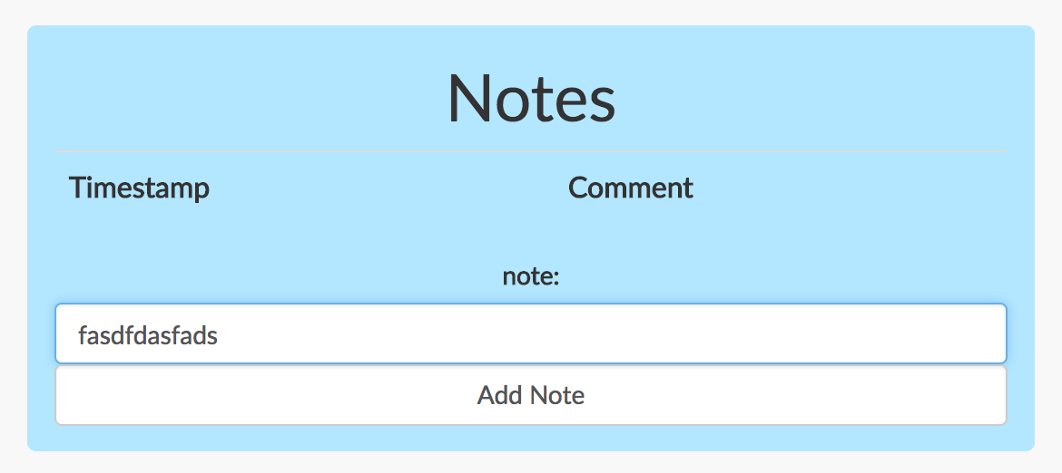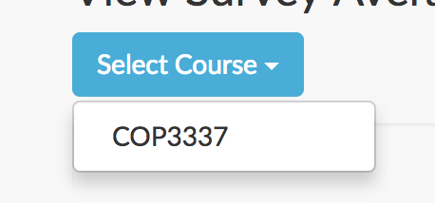

In this screen you can view individual sessions by clicking on the numbers which represent the ratings.

# Screen Shot 2017-07-28 at 3.12.07 PM.png

A modal will pop up with all the details.

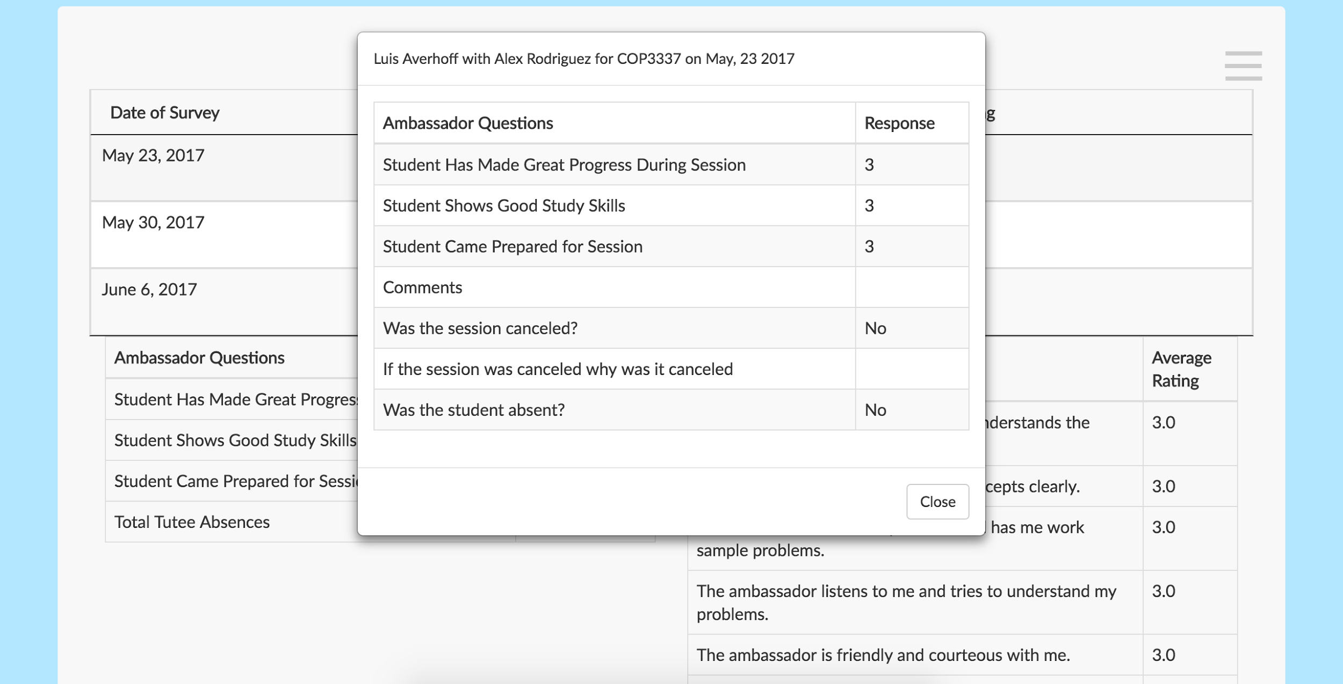

Finally, as an admin you can click on the semester report button to view the semester report. Here you can click on the individual details or download the whole report into an excel file.